THE DALLES EAST FISH LADDER
EMERGENCY AUXILIARY WATER SUPPLY PROJECT
- PROJECT INFORMATION
P2 Identifier | 142630
Project Manager (PM) | Mike Turaski (NWP, 503-808-4704)
Technical Lead (TL) | Mehdi Roshani (NWP, 503-808-4988)
Biologist/Coordination | Jon Rerecich (NWP, 503-808-4779)

- PURPOSE
The Dalles Dam Emergency AWS Project is a sub-element of the Columbia River Fish Mitigation (CRFM) program and is designed to provide emergency water supply to meet minimally adequate fish passage requirements at the East Fish Ladder (EFL).

- BACKGROUND

The EFL as currently operated passes ~90% of all returning adult fish. Water in the existing AWS conduit is currently supplied by the two fish unit turbines with no redundancy should those turbines fail. Risk to the EFL water supply is further elevated given that the addition of the Spillwall at The Dalles Dam, coupled with spillway discharge of greater than ~100kcfs, greatly reduces fish passage at the North Fish Ladder. Without a backup system, the region would need to make a choice between safe and efficient juvenile downstream passage and returning adult upstream passage.

This project was first studied in 1991 by the Hydroelectric Design Center. It was first addressed in theNational Marine Fisheries Service (NMFS) Biological Opinion (BiOp) in 1995, and again in the 2008 BiOp under Reasonable and Prudent Alternative (RPA) 28.2. Through collaboratively working with our Federal and Regional partners, the District developed an alternative that (1) reduced the flow requirement by only operating one of the three entrances, (2) removed the requirement to screen the intake, and (3) designed a route through the dam that minimized impacts and energy dissipation. A Design Documentation Report (DDR) completed April 2014 developed an alternative that meets regional goals. The alternative developed in the DDR provides a flow of 1,400 cubic feet per second (cfs), the minimum flow (under an emergency situation) the region has determined is required to keep the main east entrance operational and within acceptable passage criteria. This temporary emergency operating condition will require two of the three main entrances to be closed off, however will allow for continued safe fish passage of the preferred east entrance (which is used by approximately 80% of the returning adults that use of the East Fish Ladder).

- STATUS & ISSUES
- The construction contract was awarded in FY16, after a delay due to a bidder protest.
- Much of the construction activity is within, over, or in close proximity to the East Fish Ladder. As such, several key construction activities can only occur during the winter in-water work period (or during approved extensions at the beginning or end of the in-water work period). The project is anticipated to require two construction seasons, with construction complete in April 2018.
- During the first construction season (2016-17), the contract experienced differing site conditions, weather delays, and design changes, all of which resulted in contract modifications that are projected to cost approximately $5M in FY17. S&A and Project Support costs also increased in FY17.
- Certain construction activities that were originally scheduled for Season1 were shifted to the second season. Completing construction within the second in-water work period will be challenging.

- SCHEDULE & COST

YEAR | COST | MAJOR ACTIVITIES
FY17  Actual Obligation | $6,604,749 | Season 1 contract execution and modifications, S&A, EDC, and Project Support. Preparation of Commissioning Plan and draft O&M manuals.
FY18  PBUD | $5,000,000 | Season 2 contract execution and modifications, S&A, EDC, and Project Support. Project commissioning.

- PHOTOS & DRAWINGS
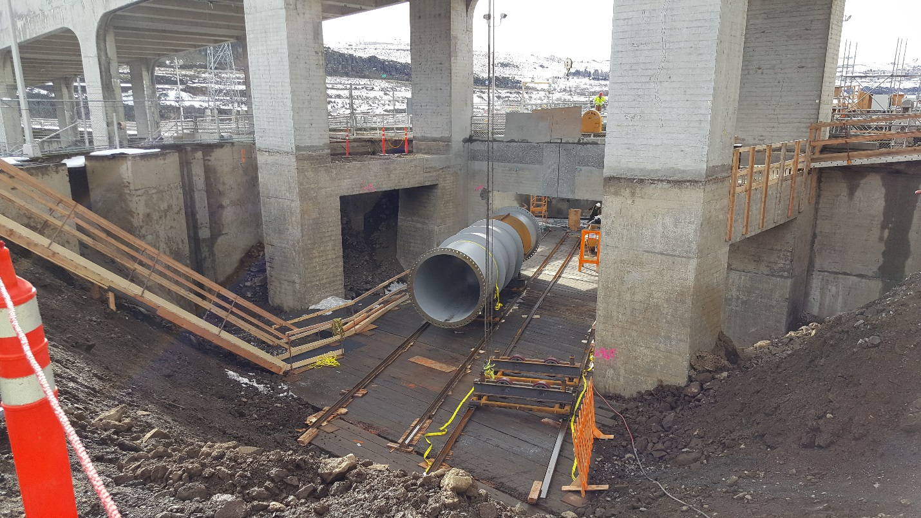
Placement of one of two 7-foot diameter penstocks that will supply water to the AWS diffuser chamber.

